GATS Teacher Training Manila, Philippines August 9-11, 2010

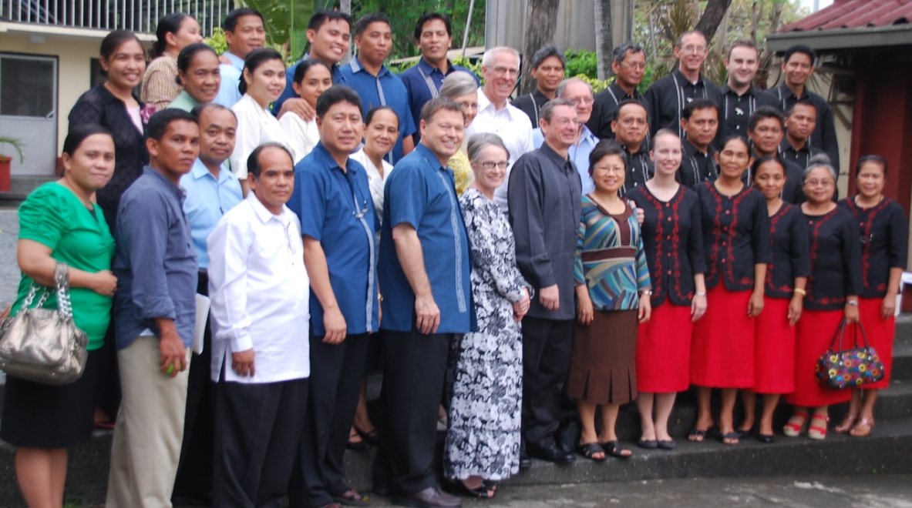
Training using the GATS Advance Educators Series and other material continued in Manila for faculty from five Bible schools in the Philippines. The three day training program was arranged by Missionary Kevin Vacca and facilitated by GTI trainers Dr. Sidney Poe and Rev. Galen Thompson.

Thirty seven leaders from five apostolic Bible schools met at the C.P. Kilgore Bible College in Manila for twelve hours of intense teacher training. Leaders in attendance included Missionaries Kevin Vacca, and John Cogan, Bible College Leader John Wolfram, their wives, and a number of senior faculty and leaders from the national Bible schools. Subjects on the agenda in 2010 included principle centered teaching, the teacher and his family, mentoring students, understanding personality, the power of positive influence, and other timely topics presented in a workshop format.

The training completes qualifying requirements for the Advance Educators Series basic faculty development course for many of these teachers. Appropriate certificates will be forthcoming from GATS leadership in the Department of Education, FMD, Hazelwood, MO.

In 2009 forty four Bible school faculty and leaders were trained in Manila, and an additional twelve faculty members in Davao.

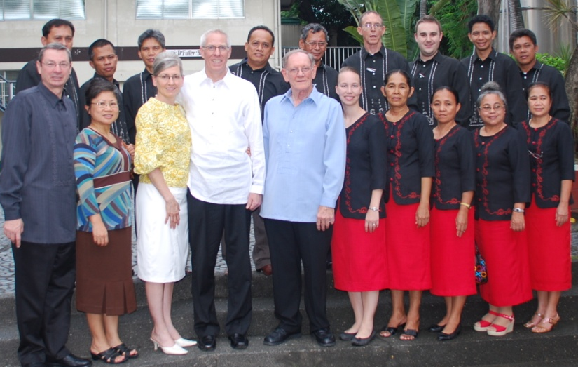
Tentative plans were made to continue GATS teacher training for a third consecutive year with facilitators Dr. Poe and Rev. Thompson in May, 2011.

Missionary Kevin Vacca and GATS workshop facilitators Galen Thompson with wife Anne, and Sidney Poe and Bible school faculty from Davao City, Philippines, 2010.

